Irement design
Automation Name
Automation
Solution Design Document
10466-Automation Engagement Dashboard


Version 1.0
Contents
1 Document control 1
1.1 General 1
1.2 Version history 1
2 Solution Design Document overview 2
2.1 Introduction 2
2.2 Using this document 2
3 Enhancement / fix summaries 3
4 Process overview 4
4.1 Process summary 4
4.2 Process flow 5
4.3 Automation structure 7
4.4 Error / exception handling 8
5 Important terms 9
6 General design 10
6.1 Requirement design 10
6.2 Decision / rationale 11
6.3 Planned A360 package usage 12
7 Applications / tools 13
8 Data and its classification / handling 14
9 Folders and files 15
10 Business stakeholder access 16
11 Reuse 17
11.1 Candidates for reuse in this automation 17
11.2 Candidates for reusable catalog 17
12 Architecturally significant design elements 18
13 Deployment design 19
- Assumptions 20

1.Document control

1.1 General
Process ID - Name | 10466-Engagement Dashboard
Process owner
NOTE: Click on the “[Subject]” document property above and type the process ID and name of the automation – this will be automatically placed in the document footer. Be careful to not delete the “[Subject]” property because doing so will prevent this “update once, display many” solution from working properly.

1.2 Version history
Version | Author name / Email address | Shibumi code* | Description | Approved by
1.0 | Sruthilaya Kuderella | 10466 | Initial Version
*A version is not necessarily based on a use case – this column is included to link document versions to the “Enhancement / Fix summaries” table below, when applicable

2.Solution Design Document overview

2.1 Introduction
The Solution Design Document (SDD) presents the high-level view of a designer’s solution to a problem. It translates the “what” described in the Process Definition Document (PDD) (e.g., what is the problem? what can be done to solve the problem? what is considered “success”?) into “how” (e.g., how can technology be used to address the problem? how will the solution be crafted?). It is the “bridge” between requirements and code.
The SDD should be authored by a solution architect or engineer tasked with crafting the solution, and it should be closely tied to the PDD that defines its scope. Formal review and approval of the SDD must precede that start of development, although development of small proof-of-concept (POC) functionality is encouraged to prove viability of proposed design approaches. The SDD for new automation should always start with this SDD template to ensure inclusion of the latest approved design content and use of current design tools. It should be maintained as a “living” document that depicts the current design of the automation. This document should be named according to the following standard:
<Process ID>_<Automation name>_SDD.docx
NOTE: Examples of requested content are provided in sections where valuable in understanding what is being requested

2.2 Using this document
Various design tools are presented throughout this document. Examples of proper tool use are provided, but if you have questions about tool use, ask a senior member of the Automation CoE. Other tools may supplement the tools provided if the designer believes these additional tools will provide greater clarity in the design approach, but these tools must not replace the standard tools presented in this document.
This document is meant to present a “high-level” view of the design. Low-level design tools (e.g., pseudocode) should not be presented in this document – such tools are developers’ “bridges” between high-level design tools such as this one and the base-level “code”.
Fixes and enhancements that alter the design of the automation must be summarized in the “Enhancement / fix summaries” section, and the detail of their impacts on design should be incorporated in appropriate sections throughout the document. Calling out these detailed design changes using in-line notes or footnotes is encouraged to help reviewers quickly identify changes included in the scope of each fix and enhancement.
Finally, the documents produced from this template are not the only “living” documents designers should be concerned with maintaining. This SDD template should be considered a “living” document, as well. Suggestions for template improvements – additions, changes, and deletions – are encouraged and can be submitted by email to:
BETO Automation Center of Excellence
NOTE: This page, all document content in blue font, and all example content in the following sections are intended to aid the designer in completing the document and should be omitted from the final document

3.Enhancement / fix summaries
Each change that alters the automation design must be listed in the table below. References to document sections modified to reflect these design changes should be documented in the “Design components affected” column.
Shibumi Code | Enhancement name / Engineer name and email / summary | Design components affected | Design approver / date
 | NA

4. Process overview

4.1 Process summary
High level description of the current process:
The proposed automation initiative is designed to automate or significantly improve the dashboard used by BETs to track partner engagements. The automation solution aims to develop a standardized, efficient system that consolidates data from multiple sources, reducing manual spreadsheet work and ensuring up-to-date visibility into engagement status. The automation solution also aims to develop a power platform that displays key milestones in the opportunity setup process, including approval stages, submission dates, and responsible parties, aiming to reduce email traffic and provide partners with self-service visibility. This solution is currently managed by the Business Enablement Team (BETs) to support the PMDs.

Automation to be:

- Raw reports will be updated daily in network drive. Copy zip files to local folder.
- Unzip and convert csv files to excel files
- Open Receivable raw report and filter column K to Tax group only and copy the data
- Paste it in receivable template file, convert few columns format and save the file
- Upload the receivable report to SharePoint
- Open Engagement summary raw report and filter column A to Tax group only and copy the data
- Paste it in receivable template file, convert few columns format and save the file
- Copy engagements numbers to Summary Dashboard and apply formulas and fill down till last row containing data.
- Copy data to template file, save file and upload to SharePoint.
- Copy Partner names to Billing sheet, apply formulas and fill down to last row containing, Copy data to template file
- Save and upload to SharePoint.
- Open SharePoint check for flag status whose status is open
- Download attachments and if pdf attachment extract data from PDF and send to LLM
- Extract required details from Pdf
- If Email attachment extract SAN Fee Range from attachment
- Update details in template summary file
- Upload to SharePoint.

4.2. Process flow:

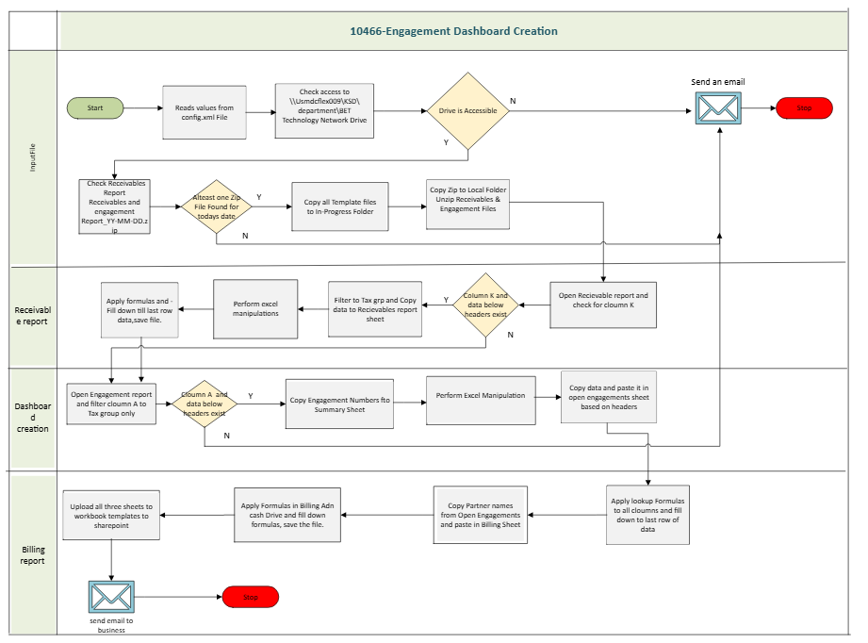

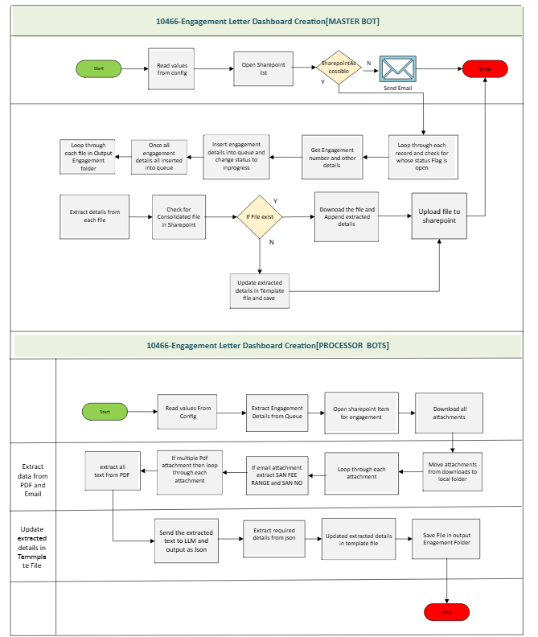

4.3. Automation structure:
10466_Engagement_Dashboard_Creation
- Unzip receivable report, Engagement summary reports and converts csv to excel files
- Filter Column K to Tax group only and copy data according to headers to Receivable template.
- Perform Formatting to Column B, H,Q. Calculate the difference between Billing date and Bill Clearing date as Invoice Aging days.
- Calculate the average of Invoice Aging days per each client and save file and upload file to SharePoint.
- Filter Clumn A to Tax group only and copy data according to headers in master template.
- Perform formatting to column C, D, G, Z. Copy engagement numbers, remove duplicates and paste in summary dashboard.
- Apply formulas to each column in engagement summary and fill down till last row.
- Save and copy data to dashboard template and upload file in SharePoint.
- Copy Partner names and remove duplicates, Paste it in Billing and Cash drive.
- Apply Formulas to remaining columns and fill down till last row containing data.
- Save file and upload to SharePoint.
10466_Launch_Task_Main_Engagement_Dashboard

- Main Task – Invokes core sub tasks
- Initialization and validation of environment.
- Validate folder access and Network Drive Access
- Check for today’s raw reports in Network Drive
- Call 10466_Engagement_Dashboard_Creation

3
10466_Launch_Task_Main_Dashboard_Creation

- Main Task – Invokes core sub tasks
- Initialization and validation of environment.
- Validate folder access and Network Drive Access
- Check for folders access
- Open SharePoint list and export data to excel.
- Open excel and filter flag status to open.
- Loop through each row and insert details to queue.

- Call 10466_Get_Input sub task

10466_Engagement_Data_Processing
- Loop through each file in output folder
- Open each file
- Extract required details from each file and update details in summary file and delete file.
- Save file and upload summary file in SharePoint.

10466_Engagement_Queue_Processing
- Extract details from queue
- Open SharePoint list with engagement ID
- Download Attachments
- If PDF extract text and send as input to LLM
- Received output as JASON extract required details
- Upload extracted details into template file with engagement name in output folder
10466_Launch_Task_Engagement_Queue
- Main Task – Invokes core sub tasks
- Initialization and validation of environment.
- Validate folder access and Network Drive Access
- Check for folders access
- Call 10466_Engagegent_Queue_Processing

4.4. Error / exception handling:

The level of detail related to error / exception handling presented in an SDD is higher than will ultimately be presented in task logic. The level appropriate for the table below addresses the primary functions within the process flow, the stakeholders who should be notified when functional issues / exceptions occur, how they should be notified, and the impact of the issue / exception should have on the automation’s continued execution.
Process step  (from the swim lane diagram) | Log type  (ALERT, ERROR) | Exception description | Action(s)
Bot cannot access Network Drive | ERROR | Unable to access network drive. | Cross check if the access is revoked/ necessary access is granted to bot id.
Bot cannot access SharePoint Library | ERROR | Unable to access Share Point | - Retry 3 times to launch the SharePoint  - Logs the exception  - Email to run team.  - Stop the bot processing.
Excel Template Exception | ERROR | Specific headers missing | - Logs the exception  - Email to business team and run team  - Stop the bot processing.
Excel Data Exception | ERROR | Data missing in raw reports | - Logs the exception  - Email to business team and run team  - Stop the bot processing.
 | ALERT | No New items to process | - Logs the exception  - End the process gracefully.
Bot cannot access Share Point List | ERROR | Unable to access SharePoint List | - Retry 3 times to launch the SharePoint  - Logs the exception  - Email to run team.  - Stop the bot processing.

5. Important terms
Use this table to define terms specific to the business process being automated. Specifically, list and define those terms that one who is unfamiliar with the business area will need to know to better understand the process and the automation solution. Introduce terms that will help the reader better understand the automation and the process it automates (terms you as a person familiar with the process already understand and believe others need to know).
Term | Definition
SP | SharePoint

6. General design

6.1 Requirement design:
In addition to providing a means of associating high-level design proposals for requirements presented in the PDD, the “Requirement design” table helps uncover additional functional and non-functional requirements. Adding entries to this table is an iterative process – as technical solutions are proposed for individual requirements, additional technical requirements and, potentially, questions about potentially new business requirements are identified.
This table helps present requirements / problems to solve and the technical solution(s) we plan to implement to meet those requirements / solve those problems. The following “Decision / rationale” table carries this further by allowing the designer to explain why the technical solution(s) were chosen to meet the requirements / solve the problems.
Requirement (functional / non-functional) | Technical design and implementation proposal
Allow for restart at any point without human intervention | - Construct logic to examine workbooks for previous work recorded  - Construct logic to evaluate whether process steps need to be performed based on the presence of files in life cycle “stage” folders

6.2 Decision / rationale
The “Decision / rationale” table is filled primarily with decisions made regarding how technical design proposals in the “Requirement design” table will be implemented from a technology perspective. The design decisions below do not necessarily relate to stated requirements. The design decisions and the rationale for making them are included to aid understanding and promote establishment of standards and best practices.
Design decision | Rationale / details
Build and maintain a column mapping XML file for all workbooks | - Allows flexibility in organization of columns (location)  - Enables addition and deletion of “non-base” columns (see definition of “Base” columns later in this document) without automation coding changes  - Provides simple column mapping for data transfer between workbooks  - Provides a simplified, non-database structure for specification of rules related to data elements

6.3. Planned A360 package usage:

This section allows the designer to forecast which A360 packages will be used for primary functions within the automation. This section is not meant to contain every package that the automation will use – just the ones that will help enable primary functions. Common functionality such as using the XML package to read and update nodes in Setup.xml and Config.xml and using the “Log to file” package to log entries to the automation’s general log file should not be listed because they are common across most automations. As development begins and code is refined, this section should be updated to reflect final package deployments and their use.
NOTE: Non-prod environment (Dev, QA, UAT) URLs are required in the following table to better enable other developers to quickly identify the web applications and sites to which they need access. Non-prod environment UNC paths for non-CoE share drive locations are also required. Differentiate between prod and non-prod by placing them in.
A360 Package | Primary use(s)
Email | To send emails to business with a summary file, Exception emails.
Data Table | To hold the data in table format which read from input excel
Excel advanced | To perform excel operations in Input file and summary file
Task Bot | To call the specific sub task
XML | To perform config.xml and steup.xml operations
Database | To connect with excel as database to do the update status in input file and summary file
Files/Folder | To create the folder in SharePoint dictionary
Browser | To launch SharePoint list
Recorder | To capture the object in SharePoint, Email Attachment.

7 Applications / tools

List the applications that will play a role in the process being automated – those applications that will provide input, those that will enable the automation to connect to data (e.g., drivers, ADE), those with which the automation will directly interact, and those that will receive output from the automation. Include only those applications that will need access to folders or files used by the automation and those the automation will directly “touch” (e.g., via “Capture”, database connection, etc.)

Application / tool | Version needed  (if applicable) | URL (if applicable) | Details (Purpose, Configuration, Bot ID permissions,  Bot ID security Group memberships)
Excel | O365 |  | Standard trust settings
Network Drive |  | Dev:  Prod: \\Usmdcflex009\KSD\department\BET Technology Network Drive | To fetch Raw Reports
SharePoint list |  | Dev:  Prod: | To Upload summary files
SharePoint  Library |  | Dev: US_BETO_Automation_COE_Power_Platform_Dev - Engagement_Dashboard_Files - Archive - All Documents  Prod: | To search and extract attachments whose flag status is open

8. Data and its classification / handling
Data is a critical asset, and it must be protected. When sensitive data is used by an automation, we must clearly document the permissions required to grant the necessary access (e.g., security group membership, application roles, etc.). We must also understand and clearly document the way we intend to move and store data throughout automation processing if the data can be moved. The first step in protecting our data is knowing how to classify it. KPMG’s data classification policy can be found in the U.S. Data Classifications Standard v1.2 and in the KPMG Data Classifications Dashboard. KPMG’s data classification ratings are:
DC0 | A DC0 classification is assigned to data and systems that KPMG US makes available to the public.  Examples of data classified as DC0 include content available on the firm’s external websites, xternal-facing social media platforms, brochures, press releases, and thought leadership. | DC2 | A DC2 classification is assigned to confidential data and systems that KPMG US makes available to specific personnel and resources on a need-to-know basis relative to legal and contractual obligations.  An example of data and a system classified as DC2 is the Client and Engagement Acceptance & Continuance (CEAC) system, which is used by engagement teams for client evaluation and acceptance.
DC1 | A DC1 classification is assigned to confidential data and systems that KPMG US makes available to general KPMG personnel and resources (e.g., systems and processes).  An example of data classified as DC1 includes content found on the U.S. Portal such as KPMG Today. | DC3 | A DC3 classification is assigned to confidential, restricted data and systems that KPMG US makes available to limited personnel and resources on a need-to-know basis relative to legal and contractual obligations, including, but not limited to, third party access restrictions, Level 3 Personally Identifiable Information (PII),  and Protected Health Information (PHI).An example of data classified as DC3 includes client provided employee health care data for KPMG engagement teams to analyze during the course of service delivery.

Data (friendly name / description) | Source (database,  data warehouse,  file system, application) | KPMG data classification rating | Data transfer encryption requirements  (at rest, in transit) | Storage location(s)  (temporary, long-term) | Technical POC name /  email address

9. Folders and files

Folder / file name | Description | Production location
Bot shared drive | To place all required files for BOT operation. | \\USDDCFlex104\AAPRD\PROD\....
Throughout the design process, files and the folders in which they are / will be housed are identified / envisioned. It is important to name these locations and the files they contain early in the delivery cycle so proper access can be discussed and provisioned in a timely manner. Place folder names / file names here, and describe them as they are identified. The production location can be added later in the design process when it is known. It is important to note that folders and files are meant to be entered separately in this table (e.g., the folder that will contain one or more files named later in the table will be listed and described as being a separate entity from the files).

10. Business stakeholder access

If business stakeholders will require access to Coe-governed file shares, or if the automation configuration deployed will necessitate moving files to locations to which business stakeholders have access, document those requirements here.
Access requirement | Action(s) required

11. Reuse
Automation components should be designed as reusable tasks when doing so may help other designers / developers avoid having to design / develop the same solution. Reusable automation components can improve the maintainability of automations, as well, by centralizing commonly-used logic – the “modify one, affect many” approach to implementing required changes). Ideal reusable tasks include those that:
- authenticate through means other than SSO to widely used applications
- read from shared data sources
- write to shared data sources
When designing a new automation or a fix or enhancement to an existing automation, examine the catalog of reusable task logic available. Reuse an existing component, if possible, rather than designing a separate piece of logic that does the same thing. Improve upon existing reusable components rather than designing and building replacements.

11.1 Candidates for reuse in this automation

Task name / | May satisfy which requirement(s) | Functionality to test /  possible modification required

11.2 Candidates for reusable catalog
Task name / | Reusable functionality

12. Architecturally significant design elements

Using tools other than those approved in our standard development toolkit (e.g., scripting, macros, etc.) may provide developers with capabilities unavailable to them through our toolkit, or they may simply provide alternate ways to do things they can already do using our toolkit. If a designer chooses to design a solution using non-standard technology, the justification for doing so must be sound – it must either be impossible or impractical to do using our standard technology, or the benefit of designing the solution using non-standard technology must significantly outweigh the costs associated with maintaining a non-standard automation.
Use of non-standard technology reduces the number of support personnel who are trained to support a solution. If support personnel who are trained in non-standard technology (e.g., Excel macros) are unavailable when an automation fails, available personnel may struggle to identify a solution in a timely manner. Additionally, when an automation fix or enhancement is required, and the change requires modifying the non-standard technology, fewer qualitied developers may be available for assignment, and this may delay or elongate design and / or development of the fix / enhancement.
Other design elements also warrant justification and proposed solution vetting because of their impact on availability of execution resources (e.g., Bot runners), their seasonal use of dedicated resources (e.g., the possibility they may be able to share dedicated Bot runners with other automations), additional cost for multiple Bot runners, or simply, their “unknowns” (e.g., they’ve never been tried before).
Use this table to document such proposed design elements and be prepared to provide a strong justification for their inclusion in your solution.
Proposed design element | Justification | Reviewer comments | Decision / date

13. Deployment design

Data in this section defines the proposed end state deployment environment (automation configuration, Bot runner requirements and configuration, Control Room folder hierarchy, etc.) Justification should be provided alongside each setting / requirement. Additional deployment elements may be added, if necessary.
Deployment element | Settings / requirements
Storage configuration
(flex, azure, on-prem)
# Bot runners
Deployment architecture
(device pool, dedicated runners, dedicated / shared runners)
Local VM drive usage (e.g., “F:”)
Control Room folder structure
Execution schedule
(Days, times, recurrence, seasonality, triggers)
Average volume of transactions / processing window (run, hour, day, …)
Execution requirements / goals
(e.g., performance, restartability)

14. Assumptions

Assumptions must sometimes be made in the absence of facts, and these assumptions may influence design decisions. Every effort should be made to replace assumptions with facts, but when this is not possible, document assumptions here, and describe their impact, if any, on design decisions.
Assumption | Design implication(s)

Appendix A - Outstanding items / to do
Design can be a long, complex process. If done well, it should ensure a shorter development cycle and a higher quality solution than a design that is rushed or whose steps are not executed thoroughly. This area serves as a “to do” list for items that need to be addressed during the current design effort. At any point in time, the designer and anyone who examines this design will be able to clearly see what questions are outstanding, whom needs to be consulted to obtain necessary information, what information needs to be added to the document to satisfy its requirements, etc.
This table should be cleared at the conclusion of each design effort (all items should be addressed / closed).
Item / to do (assigned to) | Progress / notes

Appendix B – Tech debt
Items here specify technical debt that applies to this automation. Items here constitute improvements which, if addressed individually or added to the scope of an enhancement, would not only reduce our technical debt, but would improve our automation portfolio’s quality, resilience, and / or operability. Items may remain in this list after completion of a document revision.
Item | Description / benefit

